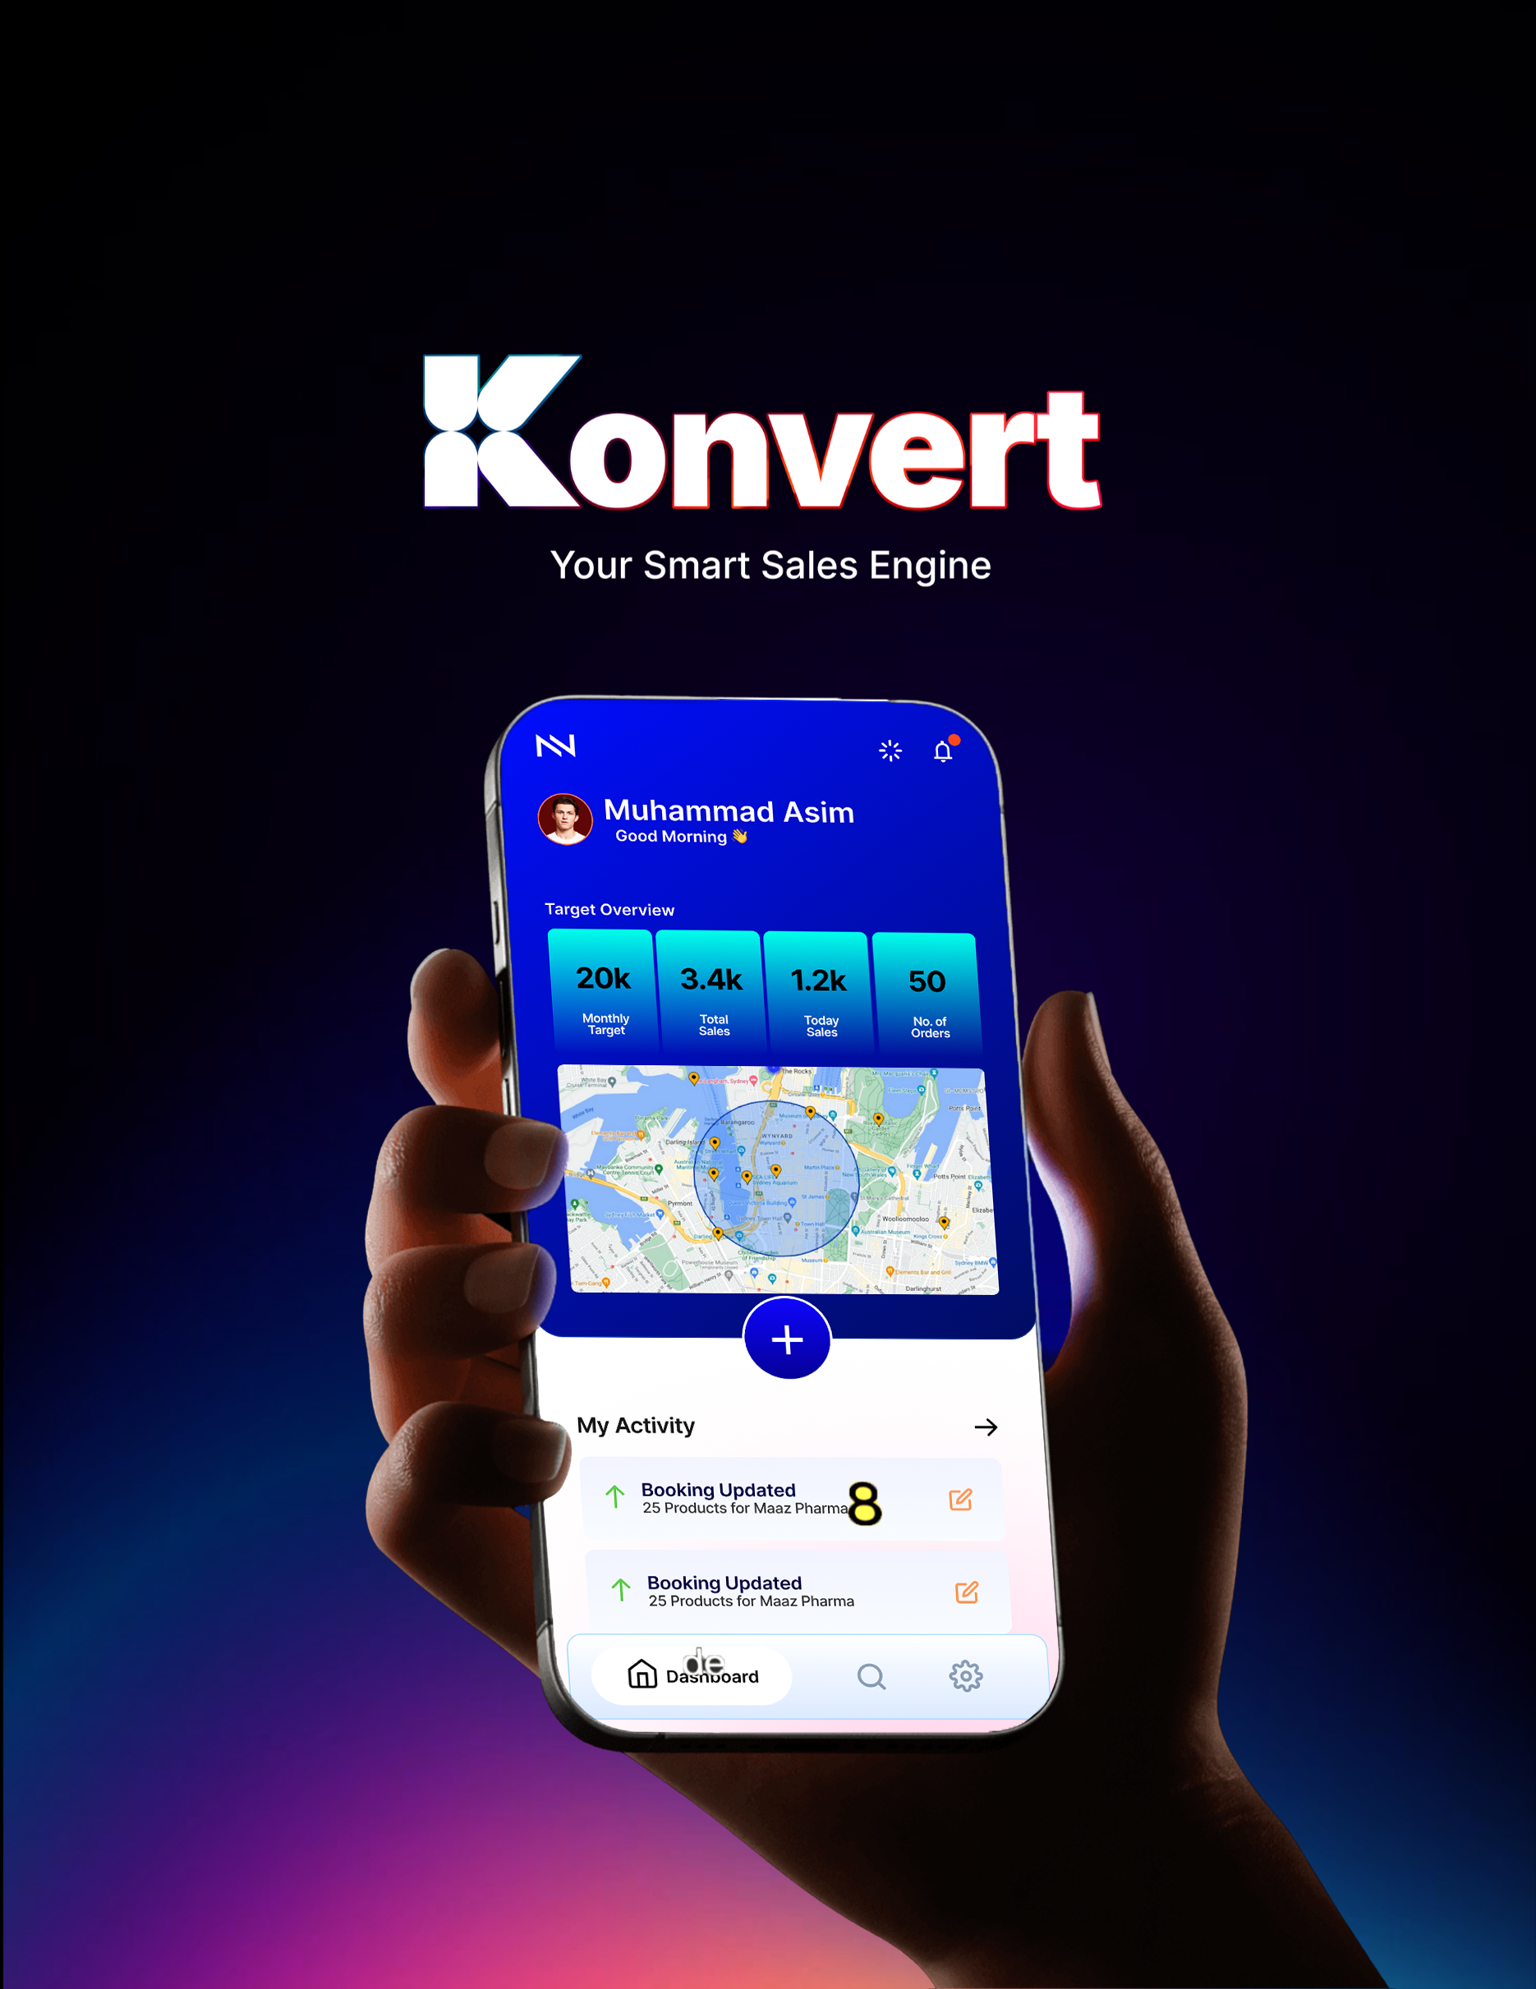



An AI-integrated business management and sales tracking ecosystem built to optimize multi-tier enterprise hierarchies, streamline distribution workflows, and give Pakistani businesses a secure, localized alternative for data-driven decision-making.

Founding Team:
Almashreq Soft

Prepared For:
Prospective Clients



Summary

Konvert is an AI-powered system that runs your entire sales operation — from the sales rep on the ground all the way up to the CEO. No matter how many layers your team has, everyone sees the same accurate, up-to-date information at the same time.
It uses AI to predict performance and tracks your sales team's routes in real time, so routine sales tasks happen automatically, and managers spend less time chasing updates. It's built to grow with your business — whether you're a small company or a large enterprise — and the whole point is simple: help you make more money from what you're already spending on sales operations.

Table of Contents
Introduction 8
Motivation 8
Project Overview 8
Problem Statement 9
Objectives: 11
Domain Analysis 13
Customer Analysis: 13
Stakeholders 14
Affected Groups and Social & Economic Impact 16
Dependencies and External Systems 17
Related Projects 18
Feature Comparison 19
Reference Documents 20
Requirement Analysis 22
Functional Requirements 22
Non-Functional Requirements 27
List of Actors 30

This page is intentionally left blank.

Section 1

Introduction

1.1

Motivation
Entrepreneurs with world-class products often face an immediate digital barrier because the sales management tools currently available are either prohibitively expensive foreign platforms or fragmented legacy systems that are too complex to master quickly. This creates a restrictive environment where businesses lose critical momentum navigating technical friction instead of focusing on their core commercial goals.
Furthermore, a reliance on external software introduces serious security risks and a total loss of data sovereignty. In the high-stakes field of sales management, the absence of a localized, secure, and intuitive engine means that vital business intelligence is often stored on foreign servers or lost in manual paperwork. There is an urgent need for a streamlined solution that allows Pakistani businesses to secure their data and optimize their sales workflows without the burden of unnecessary complexity or cost.

1.2

Project Overview

Konvert is a unified, AI-integrated sales ecosystem designed to synchronize field operations with strategic oversight, serving as the definitive automated backbone for Pakistani enterprises.
Moving beyond the limitations of traditional, reactive tracking software, Konvert establishes a high-performance technical bridge between mobile field operations and centralized web infrastructures. The platform is specifically architected to manage and optimize a complex eight-tier organizational hierarchy, ensuring that data generated by Sales Representatives on the route is instantly synchronized with executive dashboards. By integrating directly with existing web management systems, such as the Almashreqs infrastructure, Konvert eliminates the fragmentation and data silos that lead to operational blind spots, establishing a real-time “Single Source of Truth” for the entire organization.

The core of the system is a proactive intelligence engine that utilizes machine learning and advanced APIs to drive ROI through live route tracking, automated tour planning, and AI-driven performance forecasting. These predictive capabilities allow businesses to transition from defensive error-correction to proactive growth, accurately identifying future scalability and market trends. Designed for total enterprise scalability from burgeoning startups to massive distributors, the system automates mundane sales tasks and reduces operational costs while safeguarding national data sovereignty, standing as a secure domestic engine designed to empower the Pakistani workforce and catalyze national economic independence.

1.3

Problem Statement
Pakistani enterprises are currently paralyzed by a digital deadlock, caught between obsolete regional systems that fail to function and global software giants that are impossible to afford.
The reliance on fragmented, foreign legacy software has created a critical deficit in data integrity, security, and operational oversight. Organizations are forced to navigate a dual-threat landscape:

On one side,  regional platforms like SanSFE offer a broken user experience and a total lack of synchronization with central systems (like Almashreqs), leading to massive data loss | On the other hand,  world-class solutions like Salesforce or HubSpot remain financially out of reach and operationally over-engineered for the local market.

This informational asymmetry and a total lack of bi-directional synchronization between field apps and central databases result in reporting error margins often exceeding 20%. This failure to align an eight-tier hierarchy leads to significant operational leakage and strategic pivots based on obsolete data, causing the systemic erosion of market share and net profitability.

The critical bottlenecks necessitating an immediate solution include:
1. | Total Data Desynchronization  The absence of bi-directional sync between mobile field apps and web databases creates a high-stakes environment of record inconsistencies and redundant double-work.
2. | Operational Stagnation  A lack of localized, AI-driven route optimization and tour planning forces field representatives into inefficient workflows, resulting in massive resource wastage.
3. | Strategic Blindness  Executive leadership (from Managers to the CEO) is forced to operate without real-time visibility or predictive performance forecasting, leading to reactive rather than proactive management.
4. | Loss of Sovereignty  Entrusting national commercial intelligence to foreign servers creates deep-seated data-privacy vulnerabilities and long-term geopolitical risks.
5. | Economic Exclusion  Prohibitive foreign subscription costs and steep learning curves ensure that local startups and SMEs remain technologically underdeveloped.

Failure to solve these issues will result in a permanent technological dependency, where Pakistani businesses continue to bleed capital to foreign entities while operating on flawed data. Without a secure, domestic automated backbone, our industries will remain trapped in strategic blindness, unable to compete in a global economy that demands real-time intelligence and technological sovereignty.

You can read more about the problems of sales management in this digital world and its impact here:
HubSpot: 2025/2026 Sales Trends Report
Salesforce: 2026 State of Sales Statistics
MarketsandMarkets: The ROI Gap Analysis (via MeetRep)

1.4

Objectives:
Our objective is to develop the definitive automated backbone for Pakistani businesses, transforming fragmented field data into a synchronized engine for strategic growth and national economic resilience. To achieve the following strategic and technical milestones:
1. Establish Absolute Data Synchronization  To engineer a unified, bi-directional engine that bridges the gap between field-level mobile applications and central web databases, ensuring a “single source of truth” across all organizational tiers. | 2. Automate Strategic Backbone Workflows  To dismantle management overload by automating administrative sales tasks, reporting cycles, and inventory tracking, allowing leaders to shift from manual oversight to strategic growth.
3. Optimize Operational Intelligence via AI  To deploy AI-driven performance analytics and future forecasting modules that transform raw field data into actionable predictions and scalable roadmaps. | 4. Maximize Business ROI through Localized Efficiency  To increase the Return on Investment (ROI) for Pakistani enterprises by providing elite-tier route optimization and tour planning features at a fraction of the cost of foreign alternatives.
5. Safeguard National Data Sovereignty  To develop a secure, domestic business management environment that keeps critical commercial intelligence within Pakistan's borders, mitigating geopolitical and privacy risks. | 6. Catalyze Enterprise Scalability  To build a flexible architecture that empowers businesses of all sizes from burgeoning startups to massive eight-tier distributors---to scale their operations without technical friction.

We aim to revolutionize the way businesses operate in Pakistan by transforming sales management from a manual, high-friction chore into a proactive, data-driven engine. By providing an elite-tier technical infrastructure that is intuitive and affordable, we empower local industries to scale rapidly and maintain strategic momentum without relying on flawed or inaccessible foreign software.

Section 2

Domain Analysis

2.1

Customer Analysis:
The success of Konvert depends on a granular understanding of the customers who will utilize this engine as their automated backbone. Our analysis identifies two primary enterprise segments and three distinct user archetypes.

2.1.1

Enterprise Segments:
1. | Large-Scale Pharmaceutical and Distribution Enterprises  These organizations manage massive operations characterized by an eight-tier hierarchy. Their primary pain point is informational asymmetry—where field data takes days to reach the executive level. For these customers, Konvert provides a unified environment that eliminates data silos and ensures that strategic decisions are based on real-time field intelligence rather than obsolete reports.
2. | Small and Medium Enterprises (SMEs)  SMEs represent the majority of the Pakistani business landscape but are often excluded from high-tier sales technology due to prohibitive costs. Konvert offers these customers a scalable, localized, and affordable alternative to global giants. This segment values the system's ability to automate mundane tasks, allowing them to grow their operations without a proportional increase in administrative overhead.

2.1.2

User Archetypes:
1. | Executive Leadership  CEO and C-Suite  Executives require high-level, actionable insights. They use the system to monitor national sales trends, evaluate regional performance, and utilize AI forecasting to plan future market expansions. Their goal is the protection of market share and the optimization of long-term ROI.
2. | Sales Managers  Middle Managers  Mid-level managers are responsible for team productivity. They rely on Konvert to dismantle management overload by utilizing automated reporting and real-time oversight. The system allows them to identify underperforming routes and provide data-driven coaching to their teams.
3. | Field Sales Representatives  Field Workers  The primary generators of data, field representatives require a tool that reduces administrative friction. They utilize the mobile interface for live route tracking, automated tour planning, and inventory management. For this archetype, the value lies in spending less time on paperwork and more time on active sales.

2.2

Dependencies and External Systems
The functionality of Konvert is contingent upon a robust infrastructure of external services and technical dependencies that provide the specialized capabilities required for enterprise-level sales management.
1. | Centralized Web Infrastructure (Almashreq Soft)  The existing web-based business infrastructure managed by Almashreq Soft serves as the legacy data source. Konvert relies on custom API bridges to pull user hierarchies and push field activity logs to the central servers.
2. | Geospatial Services (Google Maps API)  The system integrates the Google Maps Platform for geocoding, real-time salesman tracking, and route distance calculations. This is essential for validating field attendance and optimizing tour plans.
3. | Machine Learning Frameworks  The AI engine depends on Scikit-learn and TensorFlow for training predictive performance models. These libraries allow the system to process historical field data and generate future sales outlooks.
4. | Google Firebase Ecosystem  The system utilizes Google Firebase for real-time infrastructure, employing Firestore for NoSQL data synchronization, Cloud Messaging (FCM) for instant notifications, and Firebase Authentication for secure identity management and session control.
5. | Identity and Security Services  Google Authenticator is integrated to provide Multi-Factor Authentication (MFA), securing executive-level access and sensitive commercial data.

2.3

Related Projects
To accurately position Konvert within the current technological landscape, we conducted a critical analysis of existing solutions currently serving the regional and global markets.
Regional Industry Leader

SanSFE (Regional Industry Leader)
Primarily utilized within the pharmaceutical distribution sectors of South Asia, SanSFE represents the legacy baseline. While it provides basic field reporting, it suffers from a critical lack of real-time bi-directional synchronization. Data generated on the mobile frontend often requires manual reconciliation with central web servers, leading to significant latency and high error margins in hierarchical reporting.
Global Enterprise CRM Solutions
Salesforce, HubSpot
These platforms represent the gold standard in sales management. While technically superior, they are largely unsuitable for the Pakistani SME and distribution landscape. Their prohibitive dollar-based subscription costs create a massive financial barrier, and their generalized architectures often require expensive third-party consultants to customize for localized pharmaceutical or multi-tier distribution workflows.
Smaller competition
Localized Legacy ERPs
Many local enterprises utilize custom-built or older ERP systems. These systems are typically desktop-bound or web-only, lacking the robust mobile integration required for field force tracking. They operate as static record-keeping tools rather than proactive engines, offering no geospatial tracking or AI-driven predictive analytics to assist in route planning or performance forecasting.

2.4

Feature Comparison
Feature Attribute | SanSFE (Regional) | Global CRM (Salesforce) | Konvert
Data Sync | Manual reconciliation. | High-speed cloud sync. | Localized bi-directional flow.
Mobile UI | Outdated legacy design. | Modern but complex. | Simplified field-force UX.
Reporting | Static PDF logs. | Advanced BI dashboards. | Automated localized metrics.
Cost | Moderate localized. | Prohibitive dollar-based. | Affordability for local SME.
Visibility | Immediate superior only. | Customizable/Complex. | Native 8-tier hierarchy.
Intelligence | Record-based only. | High-cost AI add-ons. | Built-in native AI engine.
Offline Work | Poor/Unstable. | Basic/Cloud-dependent. | Robust offline-first engine.
Onboarding | Lengthy setup. | Long consultant cycles. | Agile rapid deployment.
Support | Limited regional. | Remote/Indirect. | Direct local engineering.

Section 3

Requirement Analysis

3.1

Functional Requirements
The functional requirements define the operational capabilities required for Konvert to serve as a comprehensive sales backbone.

FR Module 1

Initialization, Security, and Access Control
FR-1. | System Startup Checks  The app must perform security, stability, and update checks during the splash screen sequence before granting access.
FR-2. | Error Handling and Recovery  The system must provide self-healing options (cache clear, database resync, reinstall) in response to runtime errors.
FR-3. | Domain and Hierarchy Onboarding  Users must be able to connect to a specific company domain via API keys and retrieve the specific 8-tier hierarchy.
FR-4. | Multi-Factor Authentication (MFA)  Login must be secured via Google Authenticator tokens, validated against the Almashreqs database hash.
FR-5. | Feature Locking Mechanism  The app must restrict feature access dynamically based on the user's specific role within the retrieved hierarchy.

FR Module 2

Data Synchronization and Persistence
FR-6. | Master Sync Protocol  The system must perform a full synchronization with the Almashreq cloud CRM upon login, downloading only data relevant to the specific UserID.
FR-7. | Bi-Directional Real-Time Sync  Field data (orders, logs) must sync instantly with Almashreq Database; web-side updates must push to the mobile app immediately.
FR-8. | Offline-First Architecture  The app must remain as functional as possible without internet, queueing transactions for automatic upload upon reconnection.

FR Module 3

Intelligent Dashboard and Analytics
FR-9. | AI Performance Prediction  The dashboard must display an AI-generated forecast of the user's weekly success probability based on historical behavioral patterns.
FR-10. | Target Visualization  Real-time graphs must show daily and weekly target achievement progress derived from the active tour plan.
FR-11. | Automated Notification System  A background checker must fetch and display prioritized alerts (warnings, updates, approvals) via a dedicated notification center.
FR-12. | Advanced Reporting Module  The system must generate detailed performance reports with granular filtering (daily, weekly, categorical)

FR Module 4

Tour Planning and Roadmap
FR-13. | Automated Tour Plan Creation  Users must be able to create new tour plans by selecting dates, routes, and expense budgets.
FR-14. | AI Enhancement ("Enhance Button")  The system must offer an AI-helper class to optimize the tour plan for maximum efficiency before submission.
FR-15. | Management Approval Workflow  Submitted tour plans must lock upon creation and unlock only after receiving digital approval signals from the management tier.

FR Module 5

Fieldwork and Geospatial Operations
FR-16. | Integrated Route Navigation  The fieldwork interface must embed Google Maps to show the route to the next customer without external app switching.
FR-17. | Geo-Fencing Triggers  Product selection buttons must only become active when the user's GPS coordinates enter a defined radius of the customer's location.
FR-18. | Quick-Update Mechanism  The fieldwork page must allow for rapid, localized data fetching from the server without requiring a full Master Sync.

FR Module 6

Order Management and Booking
FR-19. | Dynamic Product Selection  The system must allow users to select OTC and Regular products, applying discounts and bonuses based on current logic.
FR-20. | Daily Booking Summary  Users must be able to review, edit, and confirm daily bookings before final submission.
FR-21. | End-of-Day Upload  The system must compile all daily bookings and upload them to the Almashreqs cloud CRM for final administrative approval.

FR Module 7

Tour Plan Builder
FR-22. | Monthly Tour Calendar  Users can build a monthly tour plan laid out as 4 weeks of 7 days each, and mark every day as Field Work, Meeting, Off, Remote Field Work, or another approved activity type.
FR-23. | System-Locked Off Days  Off days are set by the system according to company policy and cannot be changed by the field user, keeping leave records consistent across the whole team.
FR-24. | Doctor Appointment Scheduling  On any day marked as Field Work, users can add doctor appointments with a chosen visit time, so each day starts with a ready-made itinerary.

FR Module 8

Attendance and Field Verification
FR-25. | Daily Geo-Verified Attendance  Every field user marks attendance once a day, and the app automatically records the time and GPS location so managers can confirm genuine presence.
FR-26. | Next-Doctor Route Guidance  The app identifies the next doctor on the day’s plan and shows the live route to that location on the map, helping the rep reach on time.
FR-27. | Visit-Hour and Location Gating  A doctor only becomes available to select for a visit once the rep’s GPS location matches the clinic and falls within that doctor’s visiting hours, so a visit cannot be logged from the wrong place or the wrong time.

FR Module 9

Samples and Digital Detailing
FR-28. | Sample Distribution Log  During a doctor visit, users can record which product samples were handed over and in what quantity, keeping a complete, auditable trail of sample usage.
FR-29. | On-Screen Product Showcase  Field users can display product images, brochures, and promotional material on-screen during a visit, giving doctors and chemists a polished presentation that supports the sales pitch.

FR Module 10

Team and Territory Collaboration
FR-30. | Joint Field Work  A visit can be marked as joint work, pairing the rep with a teammate or manager, with both users’ attendance and visit notes captured against the same call for shared accountability and coaching.
FR-31. | Cluster and Territory Management  Doctors, chemists, and geographic areas can be grouped into clusters, or territories, and assigned to specific reps or teams, keeping coverage and workload clearly divided across the field force.

FR Module 11

Master Data and Resources
FR-32. | Resource Directory  Users can view all resources assigned to them, including samples, promotional material, and budgets, from one central screen.
FR-33. | Doctor and Chemist Database Requests  Users can add new doctors and chemists to the shared database, or submit a request to update an existing record, such as a changed clinic address or timing, which an administrator then reviews and approves before it goes live.

FR Module 12

Multi-Tier Management Dashboards
FR-34. | Role-Based Manager Dashboards  Beyond the field rep, the system provides its own dashboard and workflow for every management layer — Area Manager, Regional Manager, Zonal Manager, Provincial Manager, and National Sales Manager — each one scoped to the part of the hierarchy that reports to them.
FR-35. | Product and Marketing Manager Dashboards  Product Managers and Marketing Managers get dedicated dashboards focused on product performance and promotional content, so they can track how their material performs in the field without needing access to the sales-line hierarchy.

FR Module 13

Communication and Announcements
FR-36. | Company-Wide Announcements  Admins and managers can broadcast announcements to a chosen tier or to the entire hierarchy at once, with read confirmation, working alongside the personal alerts already covered under the notification centre.

3.2

Non-Functional Requirements
The non-functional requirements define the quality attributes, design constraints, and performance benchmarks of the system.

NFR Module 1

Performance and Efficiency
NFR-1. | Rendering and Sync Speed  The Flutter UI must maintain minimum of 15 FPS for smooth navigation, and the initial Master Sync must complete within 15 seconds on a standard 4G connection.
NFR-2. | Battery Optimization  Background services, including continuous 5-minute GPS polling and AI data gathering, must consume less than 15% of device battery over an 8-hour shift.

NFR Module 2

Reliability and Availability
NFR-3. | Offline Resilience  The system must guarantee close to zero data loss during network dropouts by utilizing robust local caching before attempting Firebase synchronization.
NFR-4. | High Availability  The cloud infrastructure and Almashreqs API bridges must maintain a 95% uptime SLA to ensure uninterrupted executive monitoring and data flow.

NFR Module 3

Security and Compliance
NFR-5. | Encryption Standards  All data in transit must be secured via TLS 1.3, and local cache data (like customer PII and bookings) must be encrypted using AES-256.
NFR-6. | Breach Management  The system must auto-expire idle sessions and instantly wipe local data while alerting admins if a device security breach or root is detected.

NFR Module 4

Scalability and Maintainability
NFR-7. | Concurrent Architecture  The SQL structure and API bridges must be optimized to handle 50+ simultaneous active field agents without write-lock bottlenecks.
NFR-8. | Application Updates  The system must support forced mandatory updates and optional delayed updates (1-2 days) to ensure all tiers operate on the same compliant software version.

NFR Module 5

Usability and Compatibility
NFR-9. | Hardware Compatibility  The application must operate efficiently on lower-tier mobile devices (minimum 4GB RAM) typically deployed to regional field representatives.
NFR-10. | Human-Centered UX  Adhering to ISO 9241-210 standards, core field workflows (check-in, booking) must be achievable within three screen taps to minimize user friction.

3.3

List of Actors
The Konvert system interacts with the following stakeholders across the enterprise landscape:
- Executive Leadership (CEO / Business Unit Head)
- Tactical Managers (National / Provincial / Zonal / Regional / Area)
- Product and Marketing Managers (Cross-Functional)
- Operations Support (Command Center Operatives)
- Field Sales Representatives
- System Administrator

